Project Plan: Subscription Tracker Application
A Subscription Tracker Application is an incredibly practical and rewarding group mini-project. The core functionality centers around straightforward CRUD operations (Create, Read, Update, Delete), providing a solid foundation. From there, your team can continuously layer on complex features—like analytics, notifications, and currency conversion—to make it a standout portfolio piece.
Here is a comprehensive breakdown of the functionalities, technologies, and research phases required to build a stellar application.
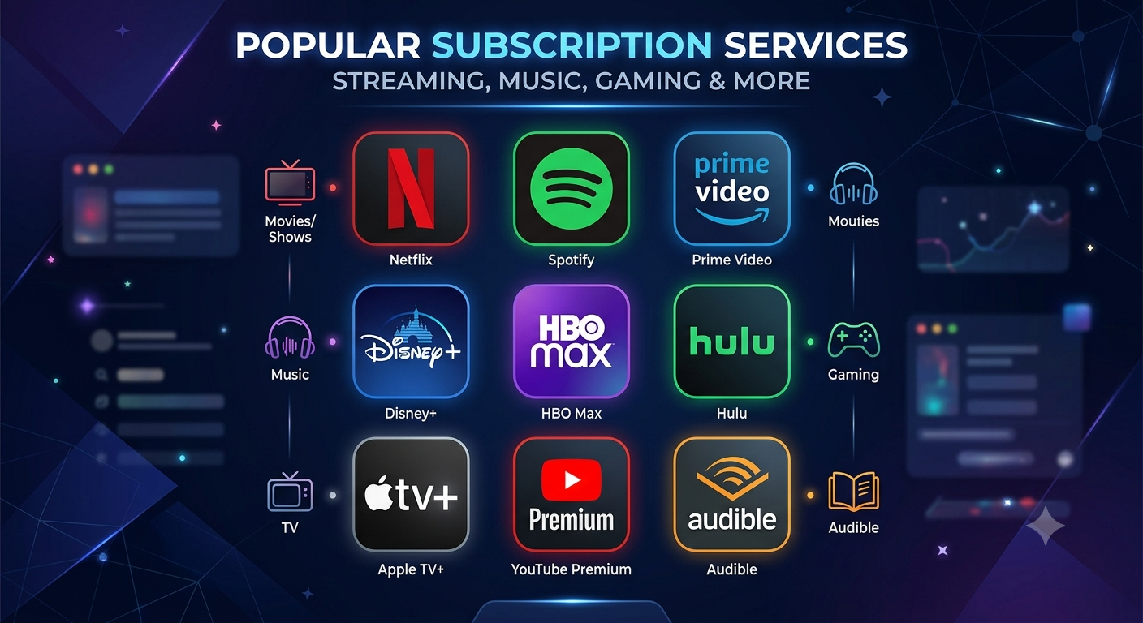

1. Defining the Platform: Mobile vs. Web
Given the nature of subscription tracking, users want to check their expenses on the go, receive push notifications for due bills, and quickly log new sign-ups.
- Native Mobile App (Android/Kotlin): Best if your team wants to learn native mobile development and achieve seamless performance with system-level notifications.
- Progressive Web App (React/Next.js): Best if you want a single codebase accessible on both computers and phones. Users can install PWAs directly to their home screens.

2. Core Functionalities (The "Must-Haves")
Start your project by building a Minimum Viable Product (MVP). Once these features work flawlessly, you have a functional app.
- Subscription Entry: Users must be able to input the service name, cost, billing cycle (weekly/monthly/yearly), first billing date, and category (e.g., Entertainment, Utilities).
- Management (CRUD): Users must have the ability to edit prices, update billing cycles, or delete a canceled subscription from the tracker.
- Dashboard & Analytics: A central view that calculates and displays total spending per month and year, along with a category breakdown (e.g., a pie chart of expenses).
- Upcoming Bills List: A chronological feed showing which subscriptions are due next and exactly how many days are left until the charge.

3. Advanced Functionalities (The "Nice-to-Haves")
Once the core is built, assign these advanced features to team members to make the app robust and portfolio-ready:
- Push Notifications: Alert the user 1, 3, or 7 days before a payment is due.
- Free Trial Tracker: A specific flag for "Free Trials" that loudly warns the user before the trial converts to a paid, recurring subscription.
- Multi-Currency Support: Allow users to track subscriptions in foreign currencies (like USD or Euros) while the dashboard converts it to their local currency using an exchange rate API.
- Brand Icon Library: A built-in library of popular logos (Netflix, Spotify, Amazon) to make the list visually appealing without requiring user uploads.
- Data Export: Allow users to export their subscription list as a CSV file or back it up to Google Drive.

4. Technology Stack Recommendations
Below are two highly recommended, beginner-friendly tech stacks featuring generous free tiers and strong AI community support.
Component | Option A: Native Android | Option B: Web / PWA
Primary Language | Kotlin | JavaScript / TypeScript
IDE / Environment | Android Studio (Free) | VS Code (Free)
UI Toolkit / Styling | Jetpack Compose | React.js or Next.js + Tailwind CSS
Local Database | Room Database (SQLite wrapper) | LocalStorage or IndexedDB
Cloud Database | Firebase Firestore (Generous free tier) | Supabase or Firebase
Deployment / Hosting | Google Play Store (Optional) | Vercel or Netlify (GitHub integrated)

5. Research & Preparation Phase
Before writing a single line of code, spend the first 1-2 weeks on project preparation.

Step 1: Competitor Research
Download apps like Bobby, SubTrack, or Rocket Money on your phones. Analyze their interfaces. Note what feels intuitive and what feels clunky, paying special attention to how streamlined their "Add Subscription" screens are.

Step 2: UI/UX Wireframing
Use a free collaborative tool like Figma (or pen and paper) to sketch your screens. Ensure you have wireframes for the Home Dashboard, the Add/Edit form, and the Settings page.

Step 3: Database Schema Design
Plan your data structure early. Below is an example of what a JSON structure for a single subscription might look like:
JSON
{
"id": "unique_string_123",
"name": "Netflix",
"amount": 15.99,
"currency": "USD",
"cycle": "monthly",
"next_billing_date": "2026-07-15",
"category": "Entertainment",
"is_active": true
}

6. AI Prompting Strategy
When you start building, use AI as your pair programmer. Instead of asking it to "build a subscription app," ask it to build specific, modular components.
Example Prompts for your Team:
For Database: "I am using Kotlin and Room Database. Write the Entity data class for a Subscription that includes name, cost, billing cycle, and next payment date."
For Logic: "I have a subscription that costs $15/month. Write a JavaScript function that calculates the total annual cost of this subscription, taking leap years into account."
For Notifications: "How do I schedule a local push notification in Android using WorkManager to trigger exactly 3 days before a specific date stored in my database?"

